DATA ANALYTICS ASSIGNMENT 3

Reshma Shaik

21NN5A0507

IV B.TECH ( CSE )

VIGNAN’S NIRULA INSTITUTE OF TECHNOLOGY AND SCIENCE FOR WOMEN ( VNITSW )

DATASET : [Sample - Superstore.xls](https://docs.google.com/spreadsheets/d/1Vmsk3xJ_qp69U0AZzCpNybqX0AP4KSon/edit#gid=972120833)

* Define at least two sets based on specific criteria from your dataset (e.g., high-value customers, top-performing products).
* Experiment with combining sets using UNION, INTERSECT, and MINUS operations.
* Create 2 Calculation field using any aggregate function
* Create any 3 visualization using quick Table Calculations

HIGH-VALUE CUSTOMERS BY SALES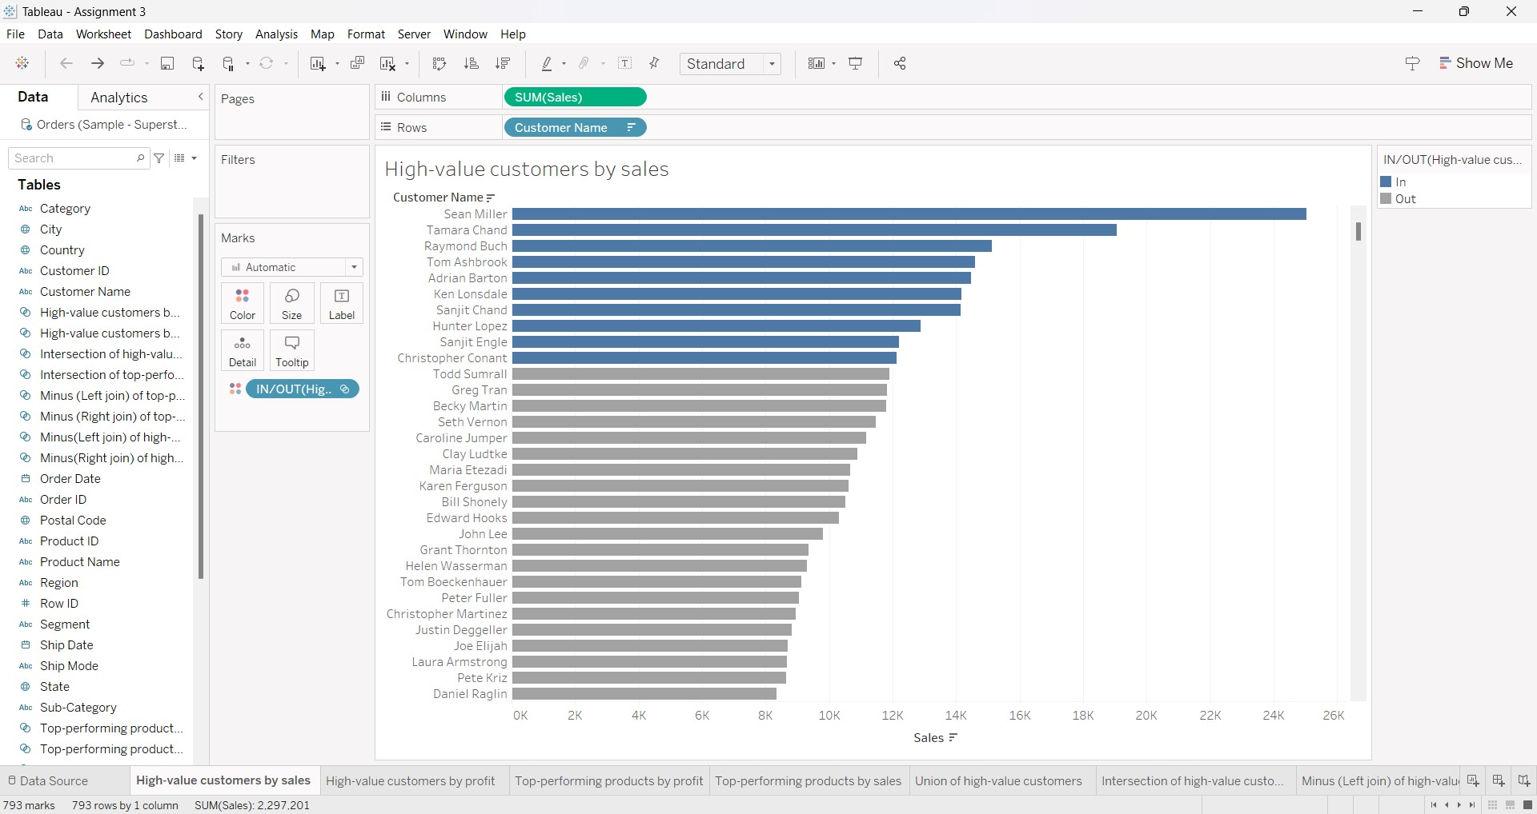

HIGH-VALUE CUSTOMERS BY PROFIT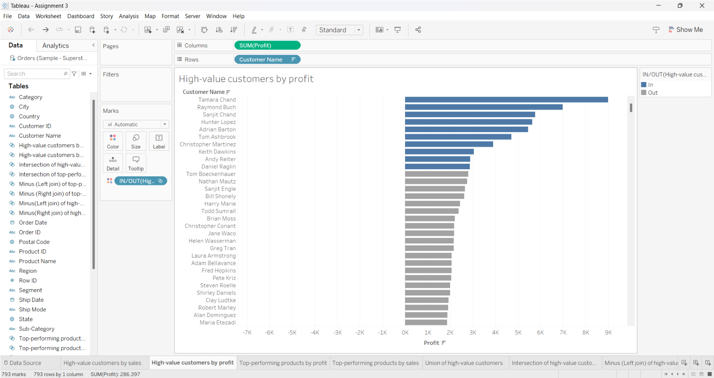

UNION OF HIGH-VALUE CUSTOMERS 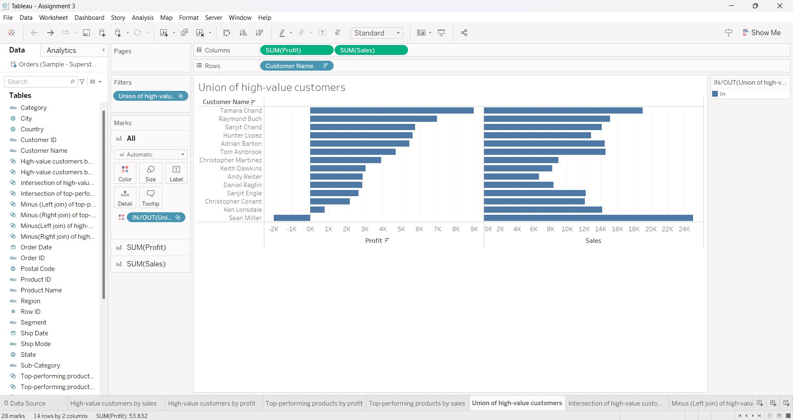INTERSECTION OF HIGH-VALUE CUSTOMERS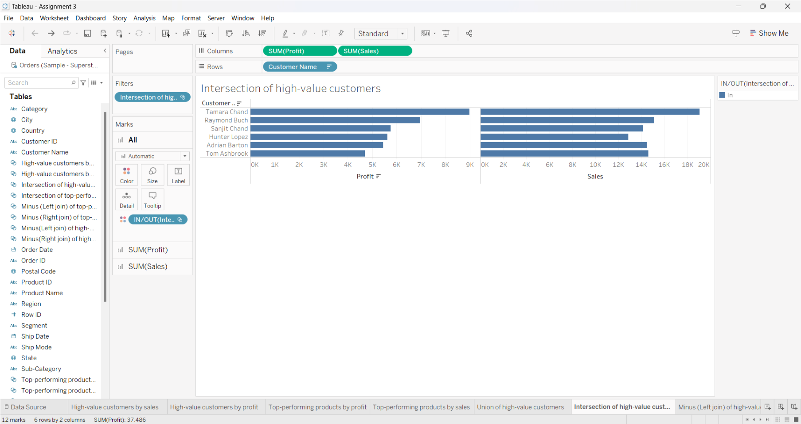

MINUS (LEFT JOIN) OF HIGH-VALUE CUSTOMERS 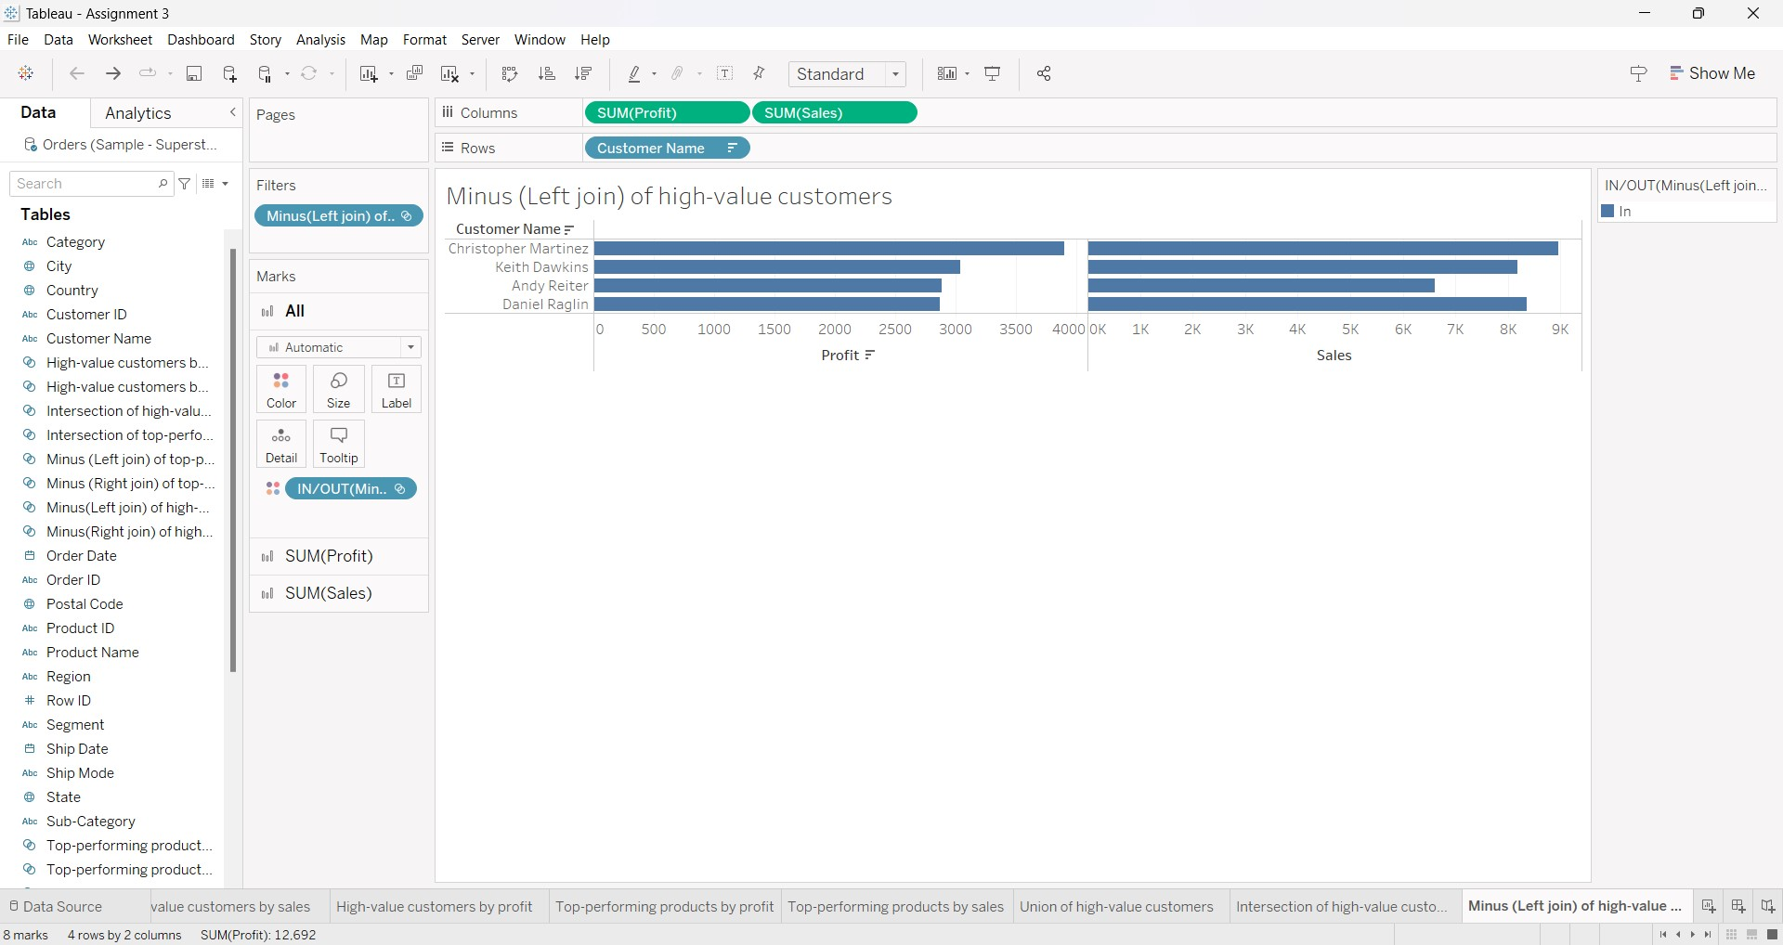MINUS (RIGHT JOIN) OF HIGH-VALUE CUSTOMERS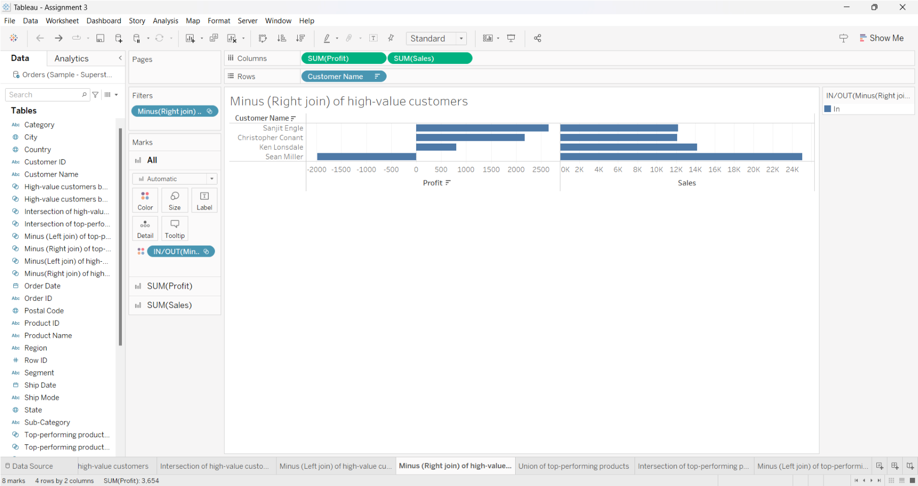

TOP-PERFORMING PRODUCTS BY PROFIT 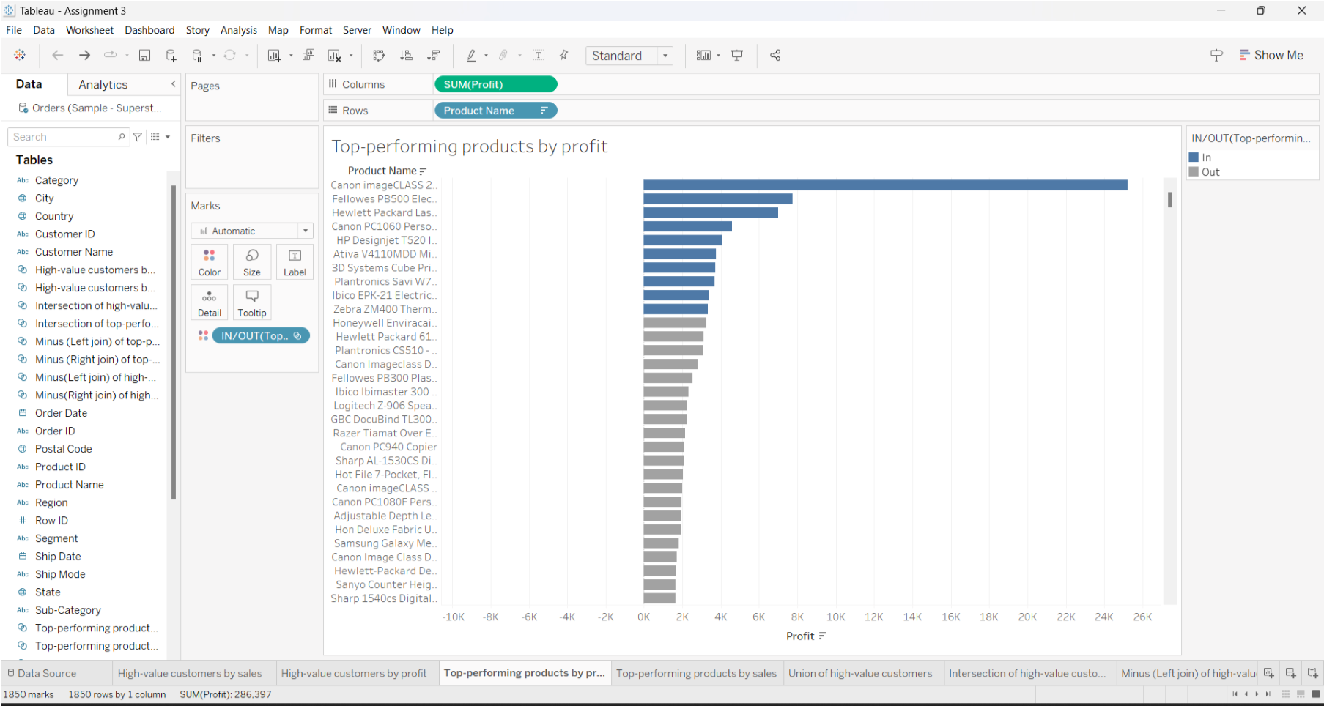TOP-PERFORMING PRODUCTS BY SALES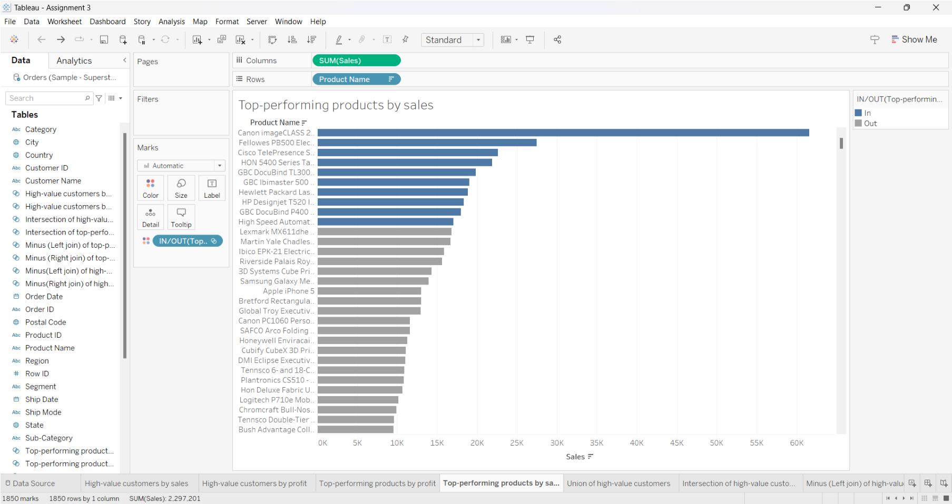

UNION OF TOP-PERFORMING PRODUCTS 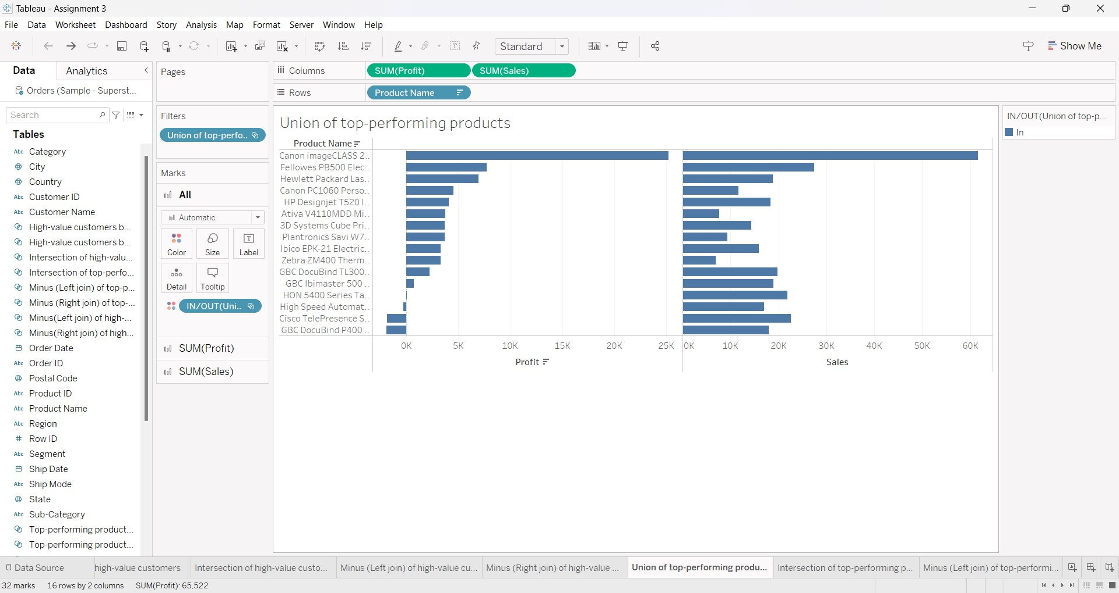INTERSECTION OF TOP-PERFORMING PRODUCTS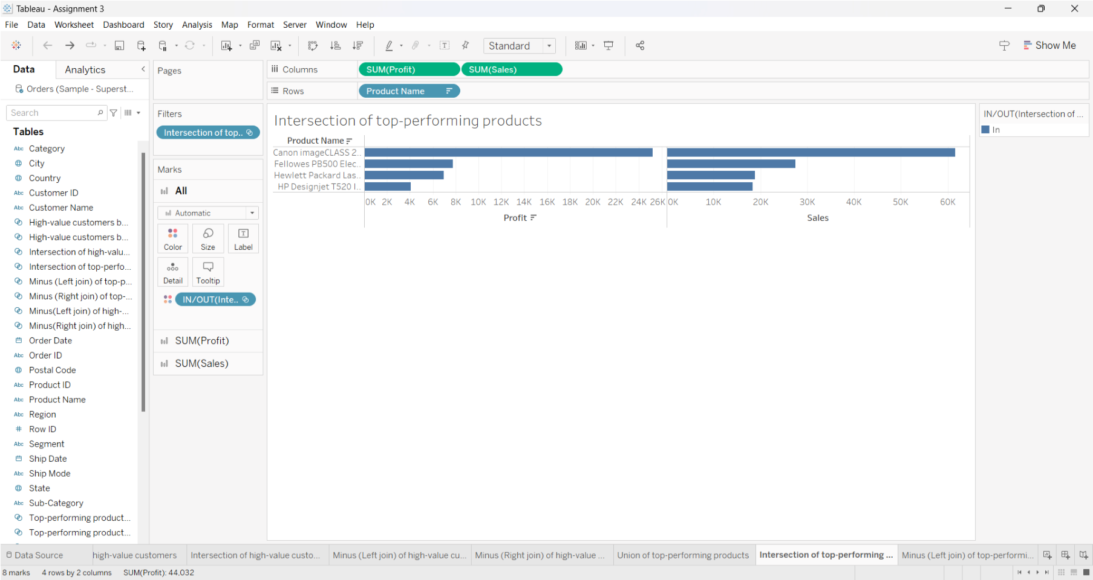

MINUS (LEFT JOIN) OF TOP-PERFORMING PRODUCTS 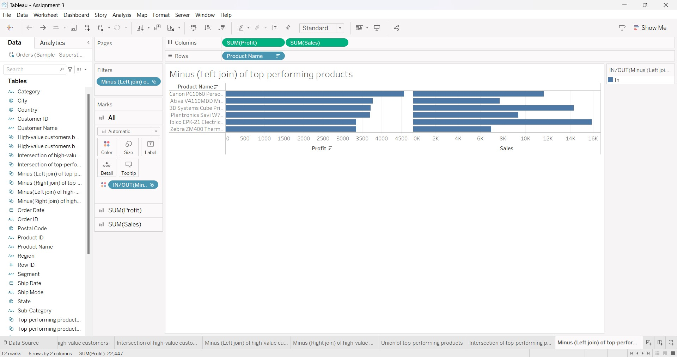MINUS (RIGHT JOIN) OF TOP-PERFORMING PRODUCTS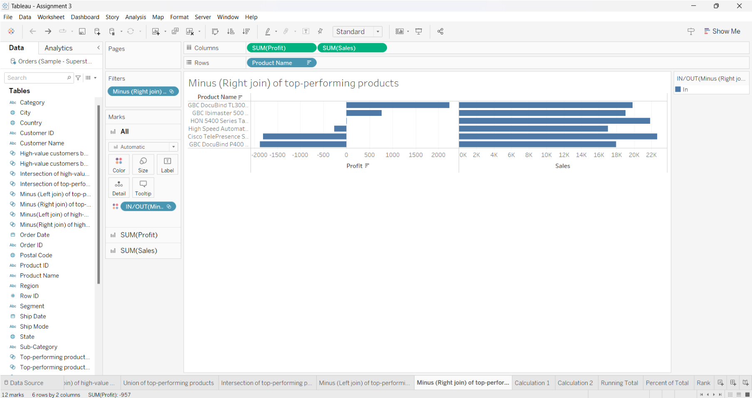

CALCULATED FIELD - 1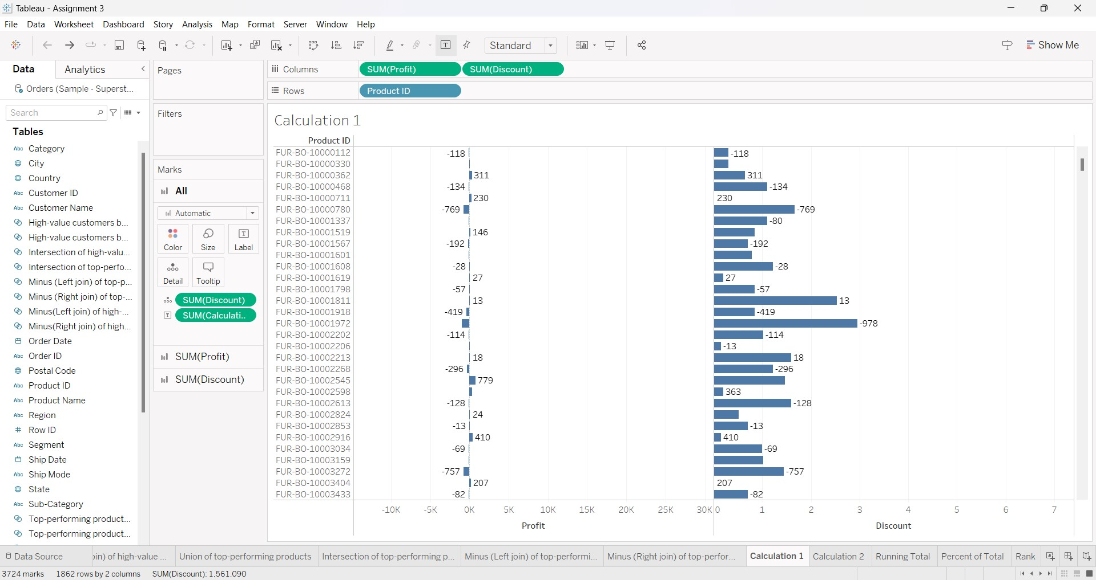

CALCULATED FIELD - 2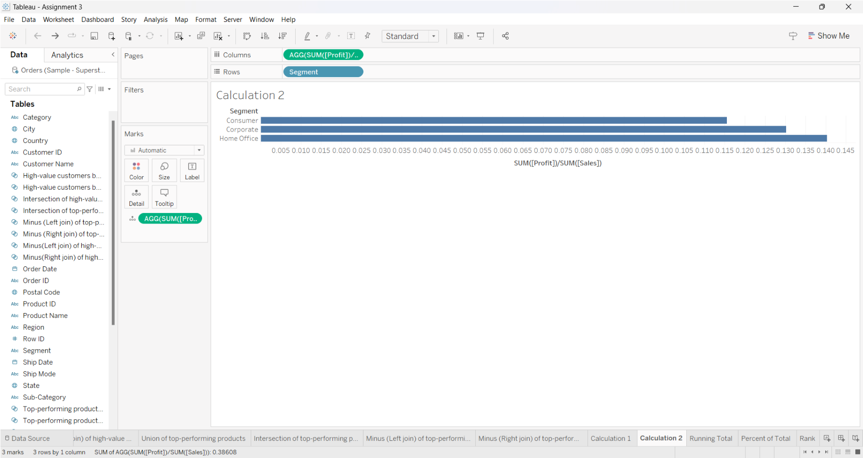

QUICK TABLE CALCULATIONS: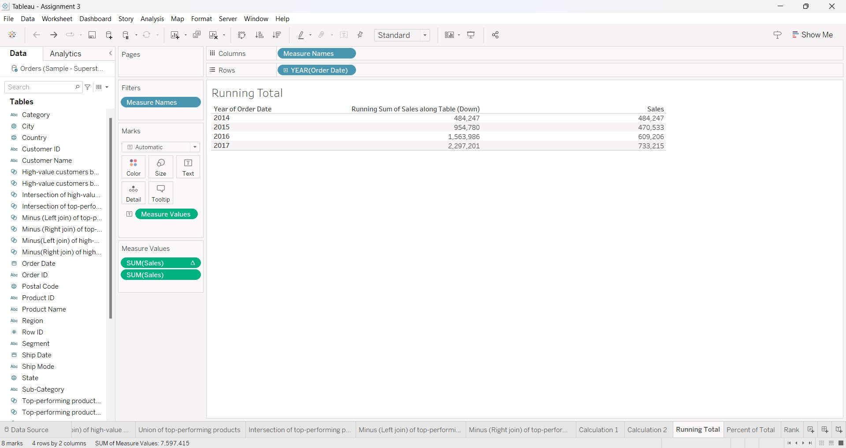

RUNNING TOTAL

PERCENT OF TOTAL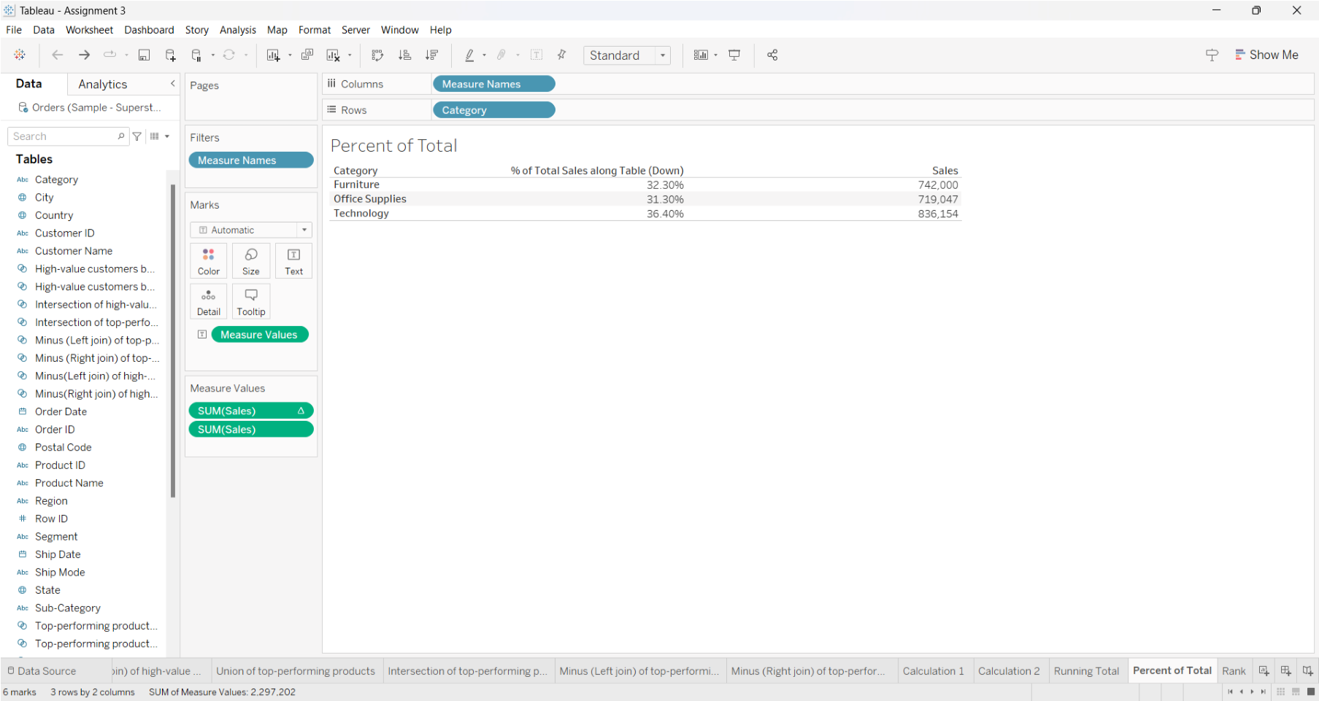

RANK